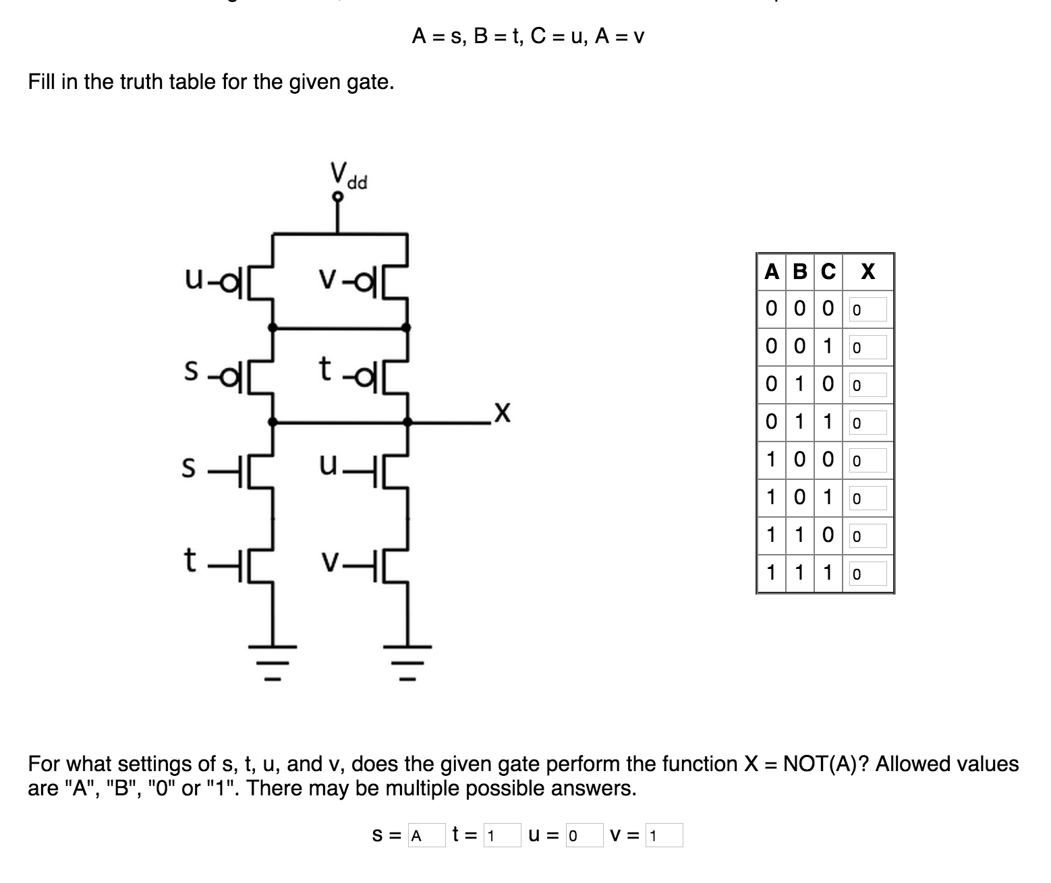

Problem 2:

Part A:

A: Impossible (I think)

B: I = Y; J = 0; K = X

C: I = X; J = Y; J = Z

D: Impossible (I think)

E: Impossible (I think)

Part B:

Ask about

Part C:

Problem 3:

Part A:

AND(A,B) = 0,0,0,1

OR(A,B) = 0,1,1,1

XOR(A,B) = 0,1,1,0

NAND(A,B) = 1,1,1,0

NOR(A,B) = 1,0,0,0

Part B:

Yes, every two input boolean function can be implemented because with the three MUX gates, you can decide on what to output on each of the four possible combinations of 2-input boolean functions.

Part C:

NOT(A) 🡪 I=1, J=0

AND(A,B) 🡪 I=0, J=B

OR(A,B) 🡪 I=B, J=1

Part D:

NAND(A,B) 🡪 I=1, J=NOT(B)  
 NOR(A,B) 🡪 I=NOT(B), J=0

XOR(A,B) 🡪 I=NOT(B), J=B

Problem 4:

Part A:

tpd(FA.S) = 8 nS

tpd(FA.Cout) = 8 nS

Part B:

tpd(MUX) = 3 nS

Part C:

tpd(S9) = 80 nS

Pard D:

tpd(S9) = 43 nS